Before planning and running the final workshops, we ran a 2 hour focus group where we gathered ideas and feedback form the young people.

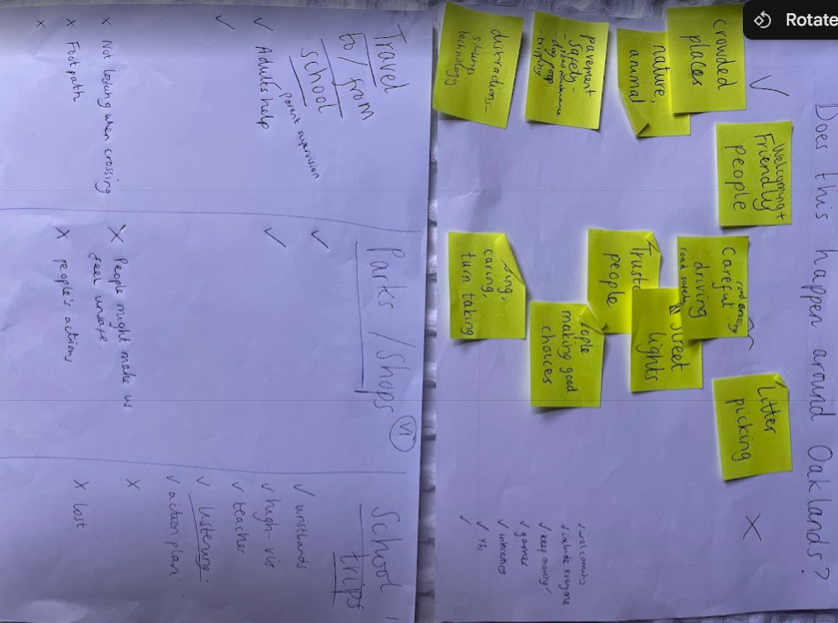
It was interactive and gave a good insight into important matters to the young people and their experience with the local area.

