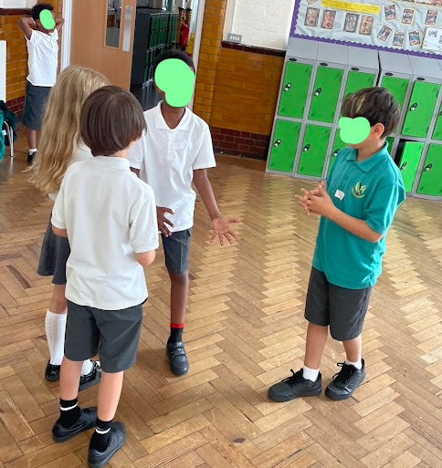
Acting Safe in Hanwell: THe children were split into groups, each with a different scenario on keeping safe in the local area. They worked together to devise 2 different endings, one which was safe and one which was unsafe. They then played these back to the rest of the group.

